CDAC – Allocation _Process – Case_Study

Important Considerations while designing the process:
- Maximum number of centers = 3
- Max no of courses = 3
- Seat capacity for each course = 3
- No of preferences allowed = 2

ER - Diagram
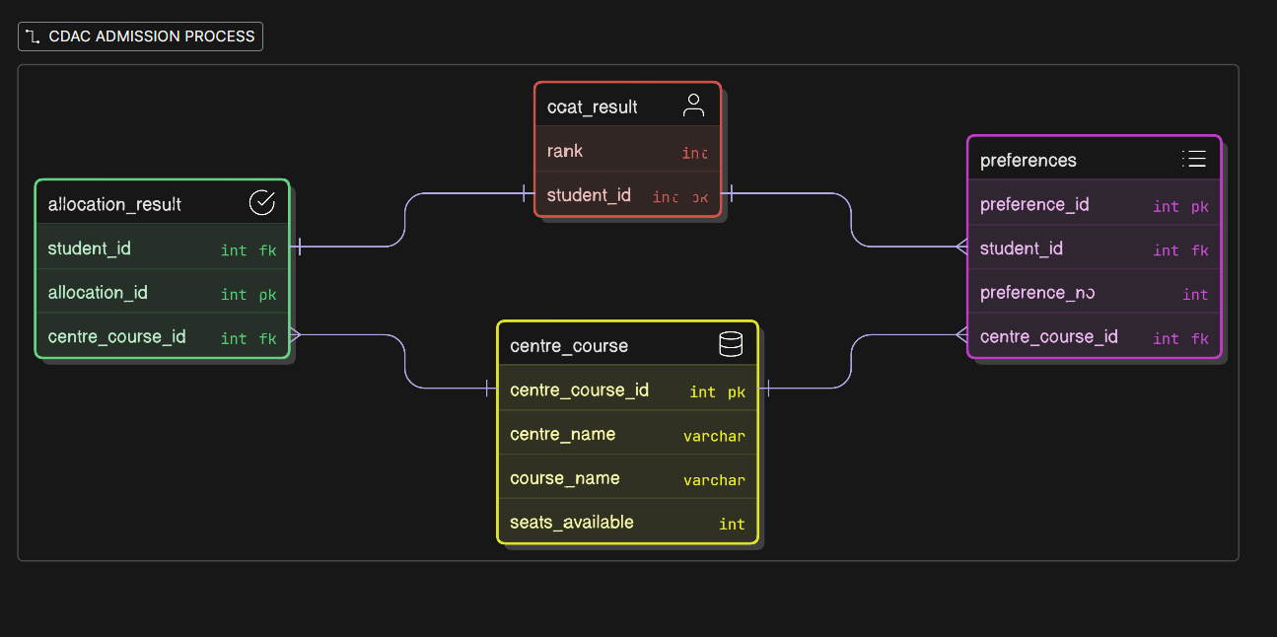

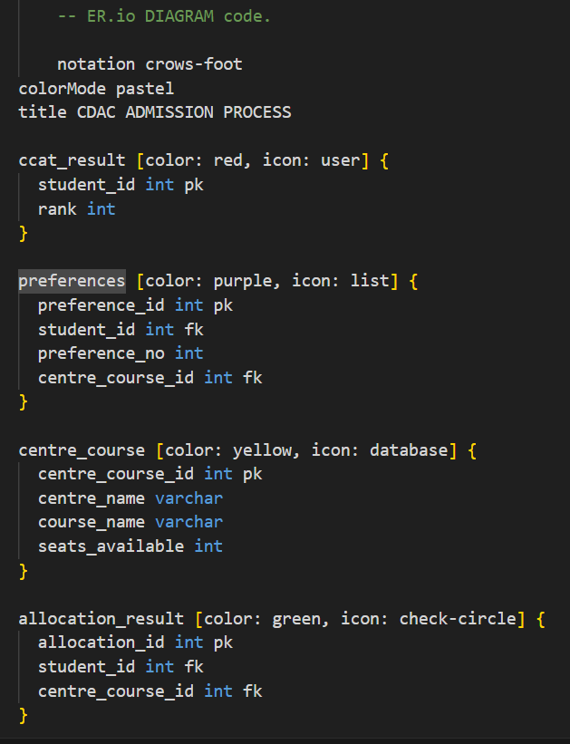

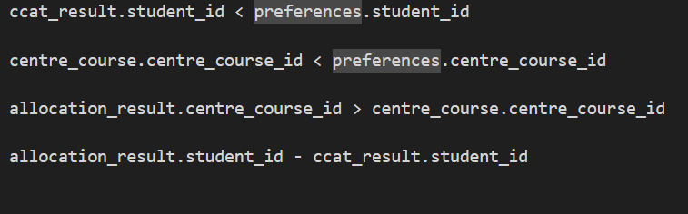

- Created ccat_rank table and modified rank value to NOT NULL.

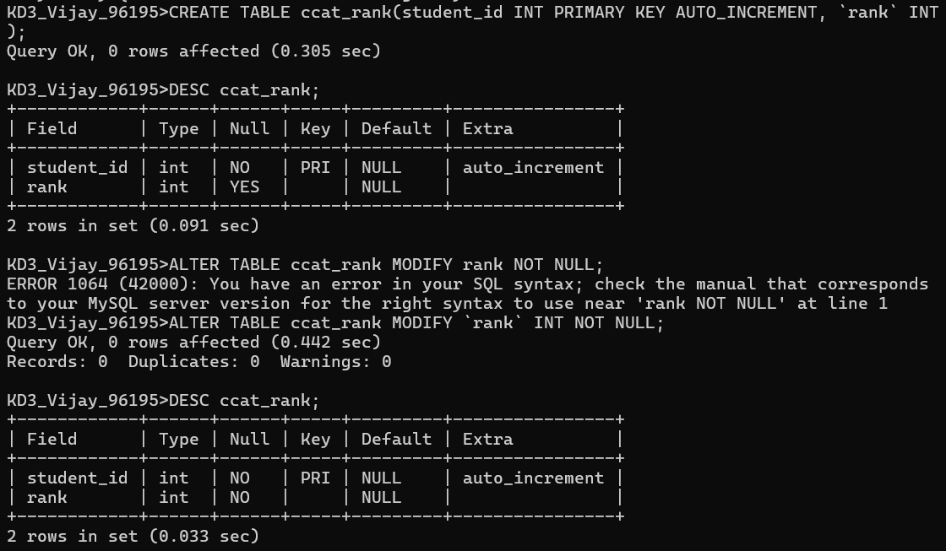

- Created centre_details table.

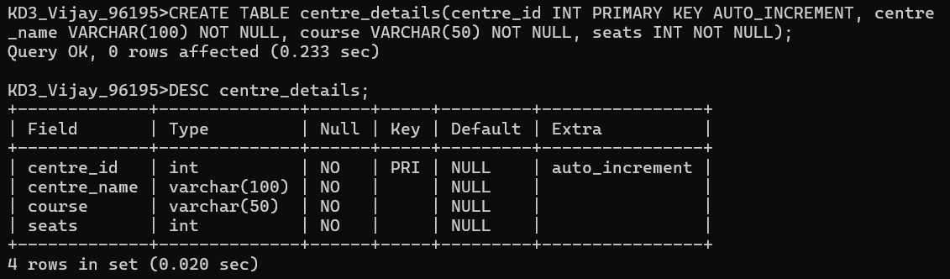

- Created preference table

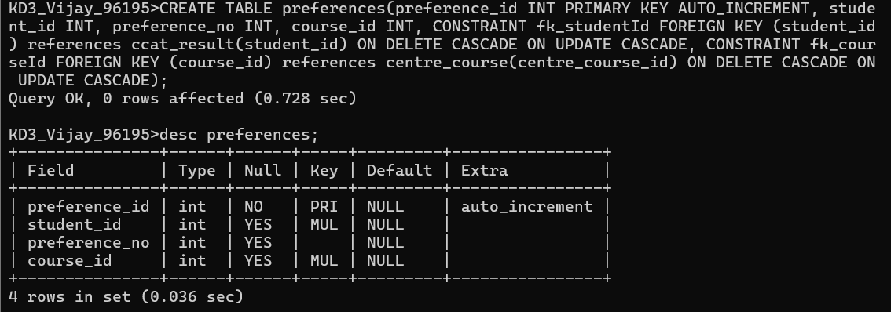

- Created allocation result table.

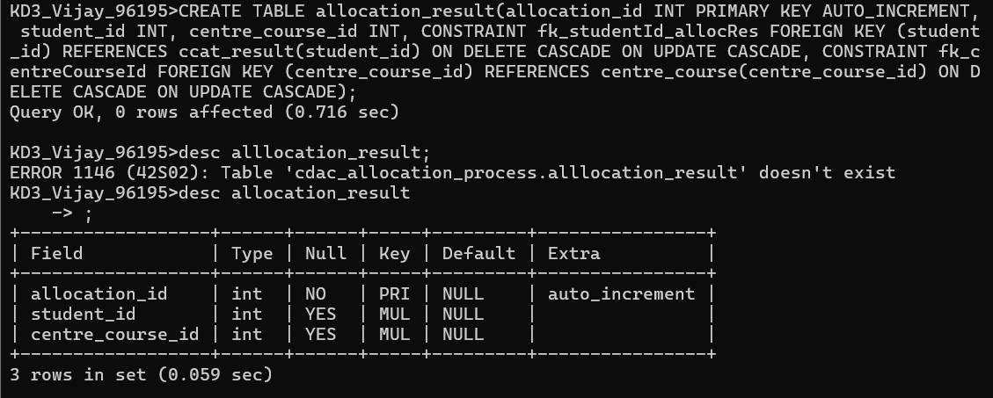

- Hardcoded data for each table

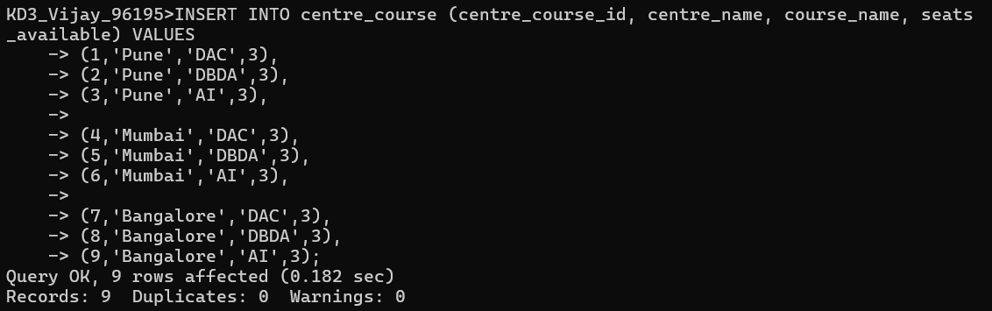

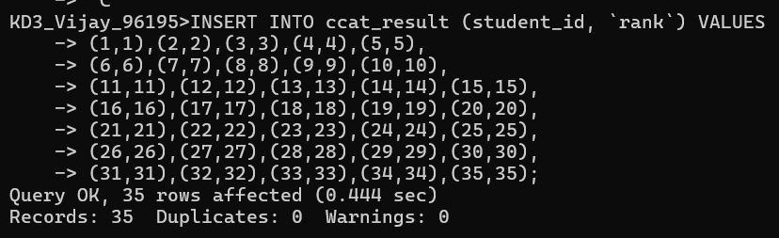

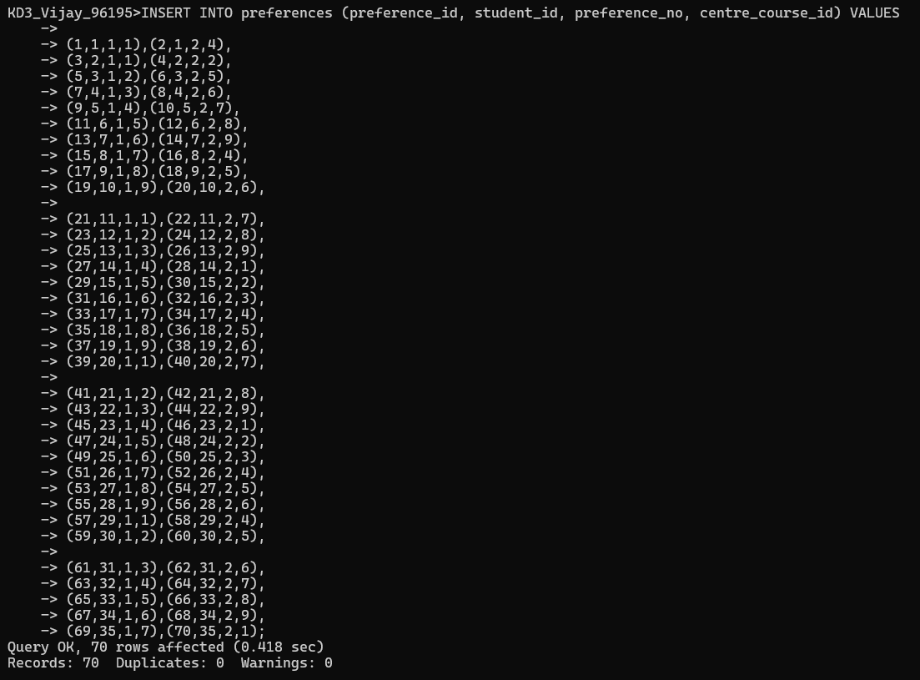

- Created Cursor Procedure for SEAT ALLOCATION PROCESS

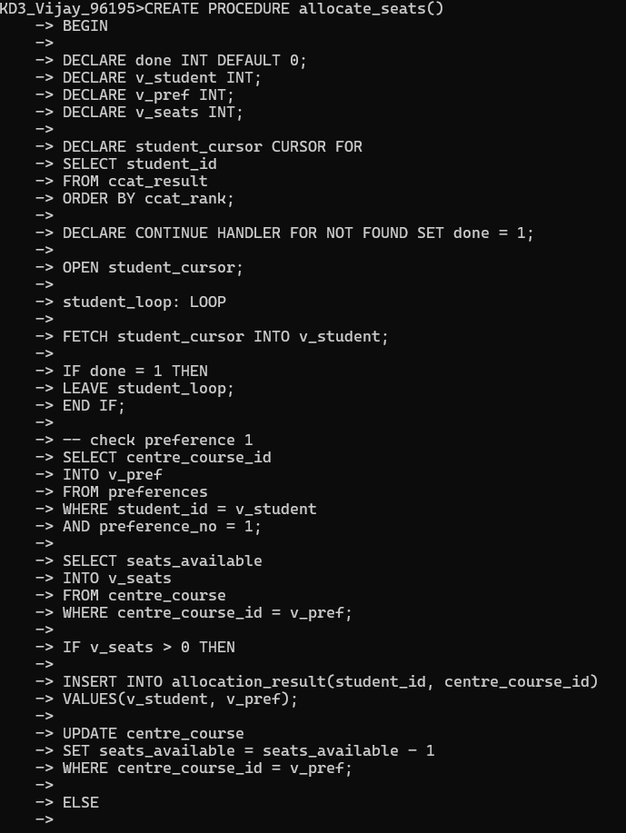

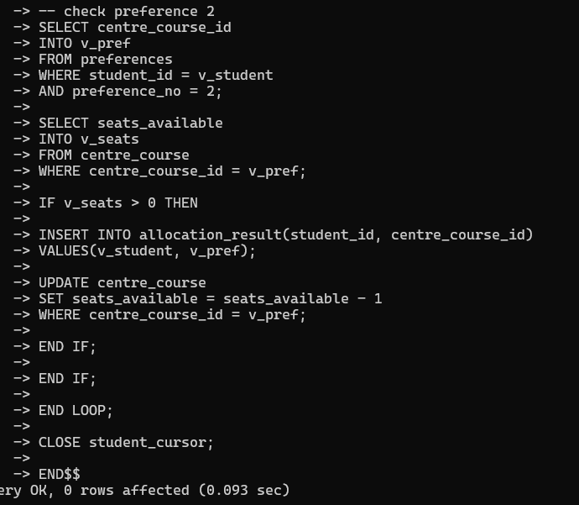

- Run the allocation process

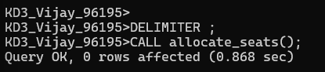

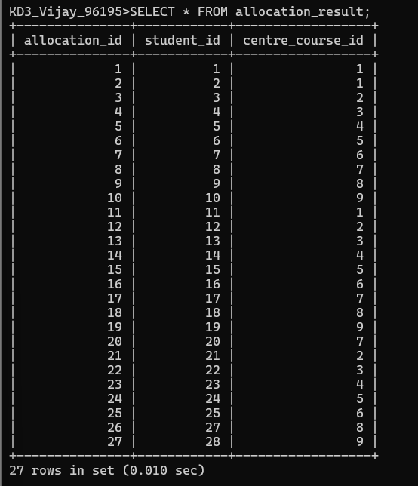

- Check seats available

